Lab 1 Inductive Sensor Report

TRC3500 Sensors and Artificial Perception

## Lab members

|  |  |
| --- | --- |
| Kun Zhang | 22701478 |
| Seow Sheng Lun | 22724281 |

# 1. Introduction

The lab practice involves the construction of a velocity sensor, which detects the speed of a steel washer. The velocity sensor, also known as inductive proximity sensor is basically a coil wound around a magnet that used for non-contact detection of metallic objects. As the washer moves through the coil, it induces a voltage (emf) in the coil according to Faraday’s law. The voltage spikes are then amplified and hold by a rudimentary signal processing circuit so that the voltage can be readily recorded.

# 2. Equipment and Components

Equipment used in this practice includes:

* Oscilloscope
* Hook-up wire
* Prototyping plug board

The following components were used for the construction of the circuit:

* LM324 quad operational amplifier (data sheets available on-line).
* Magnet and enamelled wire
* A slider and a washer
* A 2.2 $μF$ electrolytic capacitor
* Resistors ($Ω$): 100, 22K, 330K and 680K
* A silicon diode

# 3. Procedures

1. **Construction of the inductive sensor**

Firstly, a coil of 30 turns of enamelled wires was wound around a bias magnet. This is the inductive sensor and it was glued at the bottom of the slider. The ends of the coil were connected to the signal processing circuit.

1. **Initial test of the inductive sensor**

The slider was set to an angle around 75 degrees and the magnetic coil was directly connected to the oscilloscope. Then, the washer was released from the top of the plastic channel and a voltage spike was observed on the oscilloscope. This indicated that the inductive sensor worked. The result is shown in Figure 3.

1. **Construction of the signal processing circuit**

A signal processing circuit was constructed. The circuit consisted of an amplification stage and a peak hold stage. Details of the circuit are discussed in ‘Circuit’ section below.

1. **Test of the system and measurement**

We used a marker pen and marked 8 different positions away from the sensor on the topside of the plastic channel. Next, we released the washer from marked position and measured the induced voltage produced by the sensor. For each position, we repeated the measurement for three times in order to obtain more accurate results. The results are shown in the following ‘Results and Discussions’ section below.

# 4. Circuit

The aim of the circuit is to process the raw readings from the inductive sensor so that they can be readable on the oscilloscope.

The circuit consists of two stages as shown in Figure 1 below. The first stage amplifies the raw signal by 220 times. This is accomplished by using a non-inverting amplification circuit with resistor ratio of 220. The second stage holds the spikes for a longer period of time. The peak hold circuit captures the peak voltage of the spikes. Then, the captured voltage decays at a rate determined by the RC time constant. In this case, we set the RC product to be greater than 2.2s, which enables us to observe the readings longer and clearly. The charged capacitor will be discharged through the resistor, as its alternative discharging path is unidirectional as a result of the usage of diode D1. For a quicker reset of the peak-hold circuit, a switch can be added on the circuit in parallel with the capacitor.

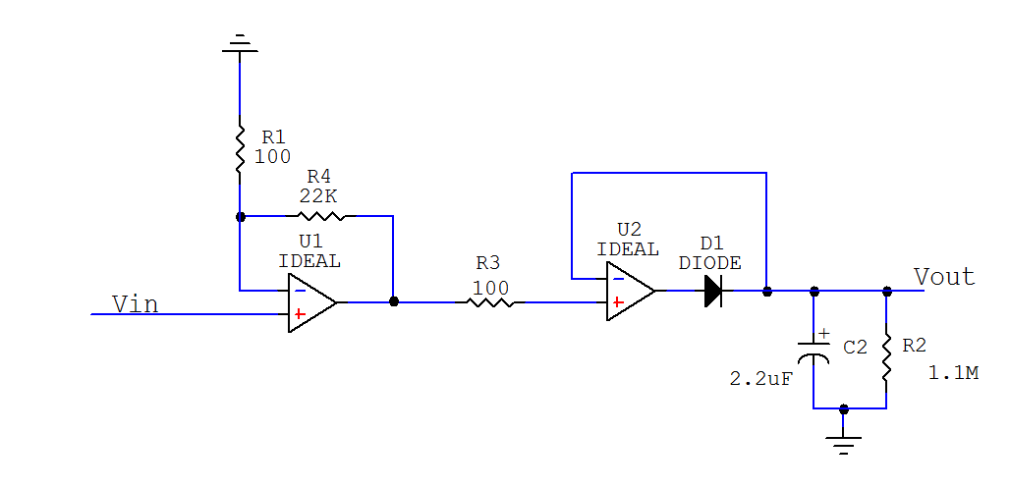

Figure 1: Schematic diagram of the complete circuit

# 5. Results

|  |  |  |  |  |
| --- | --- | --- | --- | --- |
| Distance (cm) | Vout (mV) | | | Vavg (mV) |
| 1 | 2 | 3 |
| 14 | 1120 | 1060 | 1080 | 1086.67 |
| 13 | 896 | 936 | 824 | 885.33 |
| 12 | 880 | 860 | 800 | 846.67 |
| 11 | 736 | 832 | 760 | 776.00 |
| 10 | 740 | 800 | 720 | 753.33 |
| 9 | 760 | 700 | 740 | 733.33 |
| 8 | 780 | 700 | 740 | 740.00 |
| 7 | 740 | 680 | 740 | 720.00 |

Table 1: Induced voltage with different distances from the inductive sensor

Figure 2: Induced voltage vs. distance from inductive sensor graph

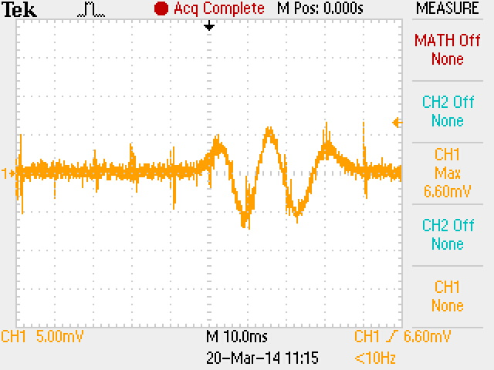

Figure 3: Induced voltage of 6.60mV from the inductive sensor

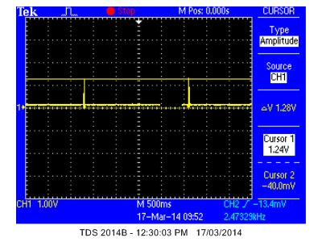

Figure 4: Induced voltage of 1.28V after going through non-inverting amplifier

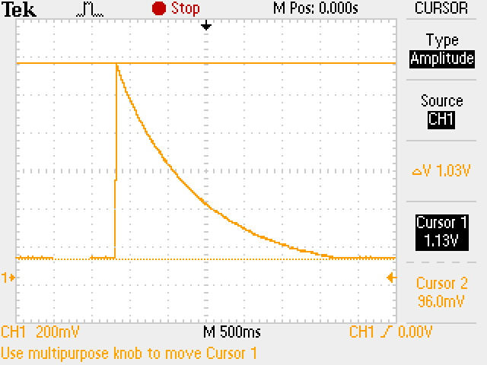

Figure 5: Induced voltage of 1.03V after peak hold circuit

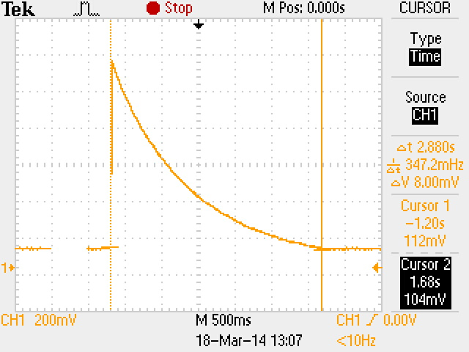

Figure 6: Induced voltage with a time constant of 2.88s after peak hold circuit

# 6. Calculations and Discussions

Theoretical results are calculated to compare with measured results.

From Figure 3, the measured induced voltage from inductive sensor is 6.60mV.

Non-inverting amplifier output voltage,

$$Vout=Vin\left(1+\frac{R2}{R1}\right)=6.6×{10}^{-3}\left(1+\frac{22000}{100}\right)=1.46V$$

Time constant of the peak hold circuit,

$$τ=RC=1.1×{10}^{6}×2.2×{10}^{-6}=2.42s$$

As we can see from Table 1 and graph in Figure 2, longer distance of washer slides to the sensor induced higher voltage (emf) where else, shorter distance induced lower voltage (emf). The measured results matched the physics theory that object dropped at a higher position achieves higher velocity, which eventually in this case, induced larger output voltage (emf) in the coil.

In Figure 4, the amplified induced output voltage recorded at 1.28V whereas the calculated theoretical output voltage is 1.46V. Further, the recorded reset time for the charged capacitor of the peak hold circuit is 2.88s as shown in Figure 6. This is larger than one time constant of 2.42s, which indicates the decaying is really fast.

As we know, the theoretical results are calculated based on ideal components, where in real life condition; components are always imperfect which explained why the measured results are difference compare to theoretical results. Therefore, the measured results are acceptable.

# 7. Issues Encountered

1. Wind 50 turns of enamelled wire around the coil was tricky– The given magnet was too small to be coiled by 50 turns of enamelled wire as instructed in the lab manual. In the end, we only managed to coil about 30 turns of enamelled wire, which was good enough to obtain an induced voltage. If 50 turns were used, the induced voltage would have been much higher and a better result could have been obtained.
2. Surface of the washer and plastic channel – The surface of the washer and also the plastic channel were a bit rough, which affected the sliding process. Due to that, higher velocity could not be achieved and thus larger induced voltage could not be obtained.
3. Noises from unused op-amps – LM324 quad operational amplifier chip consists of 4 op-amps but only 2 were used for the circuit. The unused op-amps produced noises to the circuit, which affect the induced output voltage. Therefore, the unused op-amps input gates need to be grounded to reduce the noise.

# 8. Applications

Inductive sensors are used for detection of conductive objects such as metal and carbon at a short range. They are distinguished by a long operating life and extreme robustness. A lot of applications can be benefited from using this sensor such as end of the line detection in a factory production line, speed sensing (in this experiment), security detection for home security system, position detection and many more.

# 9. Theoretical Relationship

From the perspective of energy conversion, the gravity potential energy of the washer converts to kinetic energy, which in turn converts to electric energy in the inductive sensor. Therefore, a washer released from a higher position will have a greater velocity when it reaches the bottom and will induce a larger electric potential in the coil.

The magnetic field around a bias magnet is inhomogeneous. As a result, if a washer (a conductor) passes through the magnetic field of the magnet, its magnetic flux changes [1]. A higher speed of the washer leads to a greater change (disturbance) in its magnetic flux and hence a larger potential induced in the coils according to Faraday’s law.

In short, it is concluded that a washer released from a higher position has higher speed and can generate larger potential in the inductive sensor.

# 10. Conclusion

In this experiment, an inductive sensor has been adequately created and tested. The low induced voltage has successfully been amplified and hold through a non-inverting amplifier and peak hold circuit respectively to achieve a readable and acceptable output voltage. Besides, we also learnt that longer and higher slide distance away from the inductive sensor induced larger output voltage (emf) which also matched the physics theory of higher drop position can achieves higher velocity. In conclusion, inductive sensor is a very useful switch in lots of applications.

# Reference

[1] C. Coillot & P. Leroy, Induction Magnetometers: Principle, Modelling and ways of improvement, Intech Open Access Publisher